Lab 7

Task 1:

void setup() {

pinMode(11,OUTPUT);

}

void loop() {

analogWrite(11,63.75); // 25 % duty cycle

delay(200);

analogWrite(11,127); // 50 % duty cycle

delay(200);

analogWrite(11,191); // 75 % duty cycle

delay(200);

analogWrite(11,255); // 100 % duty cycle

delay(200);

}

Output:

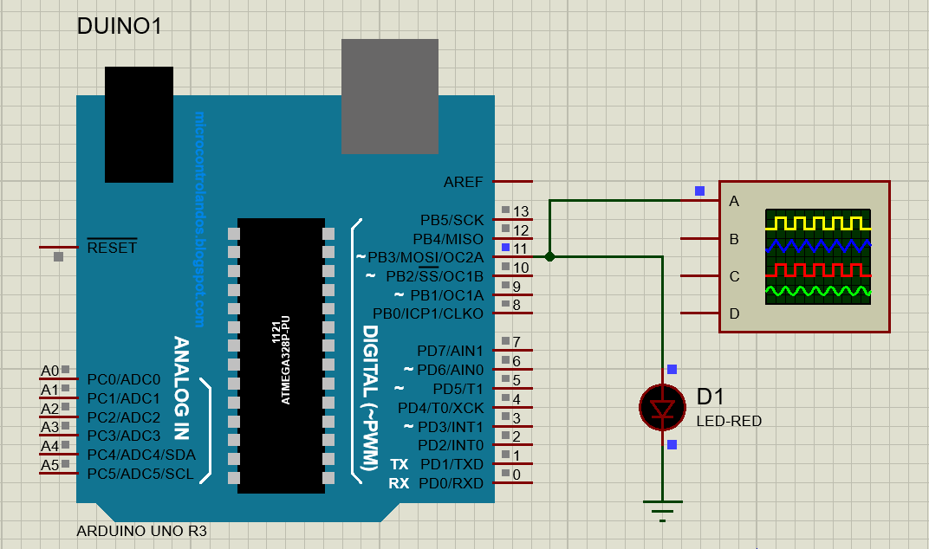

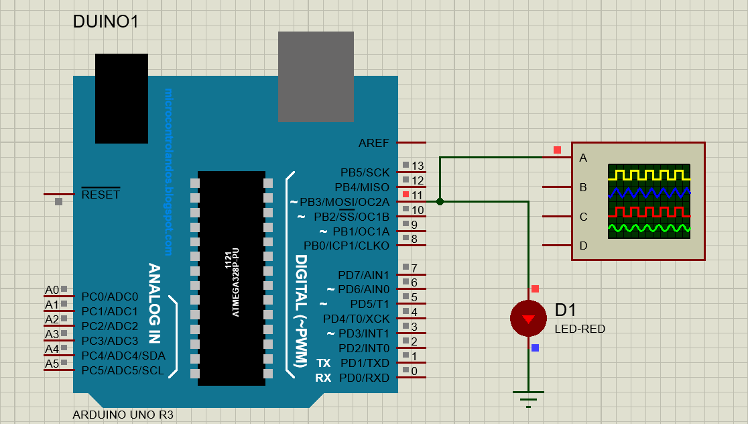

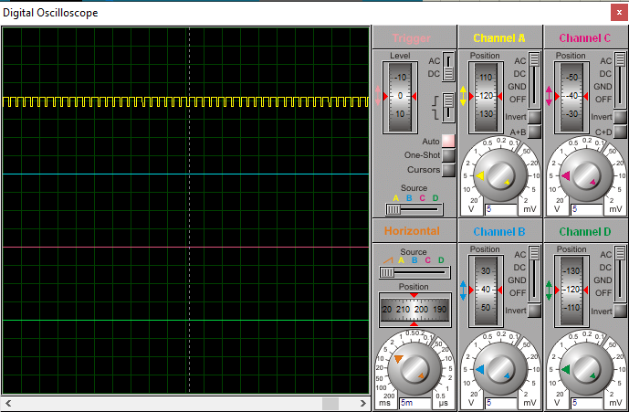

Task 2:

int in1=10;

int in2=9;

int en=8;

void setup()

{

pinMode(in1, OUTPUT);

pinMode(in2, OUTPUT);

pinMode(en, OUTPUT);

}

void loop()

{

digitalWrite(en, HIGH);

digitalWrite(in1, HIGH);

digitalWrite(in2, LOW);

delay(5000);

digitalWrite(en, LOW);

delay(1000);

digitalWrite(en, HIGH);

digitalWrite(in2, HIGH);

digitalWrite(in1, LOW);

// Activating the Channel 1 of L293D.

// Making the in1 at HIGH Logic Level.

// Making the in2 at LOW Logic Level.

// Wait for 5 seconds.

// De-Activating the Channel 1 of L293D.

// Wait for 1 seconds.

// Activating the Channel 1 of L293D.

// Making the in2 at HIGH Logic Level.

// Making the in1 at LOW Logic Level.

delay(5000);

digitalWrite(en, LOW); // De-Activating the Channel 1 of L293D.

delay(1000);

}

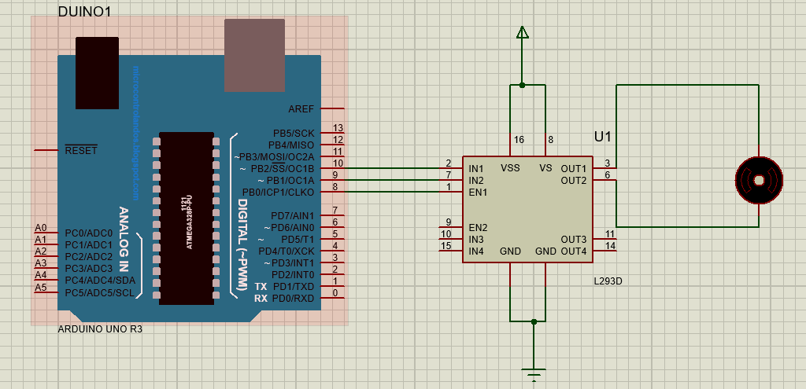

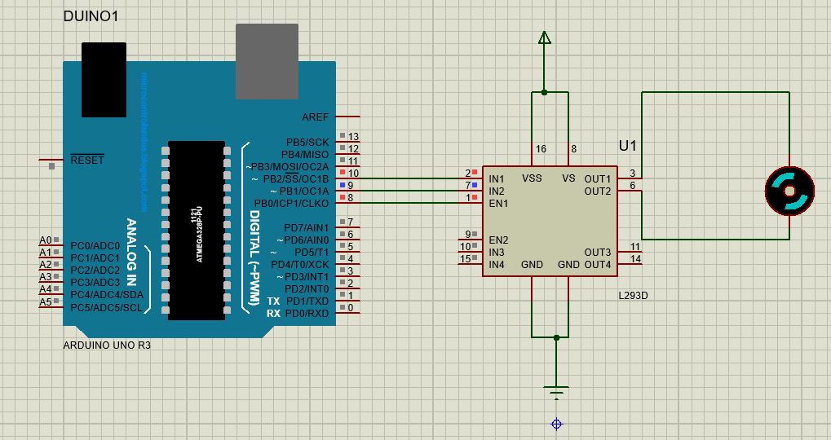

Task 3:

int pwm = 10;

void setup() {

pinMode(pwm,OUTPUT); //make 10th pin as output.

}

void loop() {

delay(100);

analogWrite(pwm,10);//slowest speed

delay(1000);

analogWrite(pwm,50);

delay(1000);

analogWrite(pwm,100);

delay(1000);

analogWrite(pwm,150);

delay(1000);

analogWrite(pwm,255); //255 belongs to full speed

delay(1000);

}

Output:

